**PE SPRING 2021 Paper No.2**

**Q1:** Nhap vao ban kinh x, tinh dien tich hinh tron den 2 chu so thap phan, pi = 3.14

Vi du:

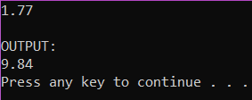

**Q2:** Nhap n, tinh (n+1)!

Vi du:

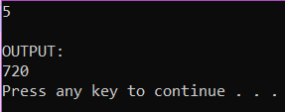

**Q3:** Nhap n, neu la snt thi in ra 'n is a prime number', khong thi in ra 'n is not a prime number', voi n la so duoc nhap vao

Vi du:

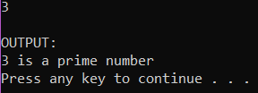

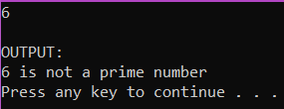

**Q4:** Nhap vao chuoi 'o'. In ra chuoi nguoc lai

Vi du:

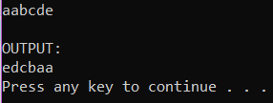

**Q5:** Nhap vao chuoi 's' voi len(s) < 100, in ra chuoi viet hoa cac chu cai dau moi tu

Vi du:

**Q6:** Nhap n, nhap vao n so nguyen, sap xep n so nguyen, in ra cac so chan theo thu tu giam dan, giua 2 so in ra co dau xuong dong \n

Vi du:

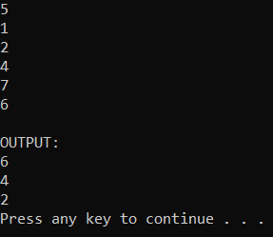6

**Q7:** In ra hinh thoi ngoi sao voi chieu cao n nhap tu ban phim

Vi du:

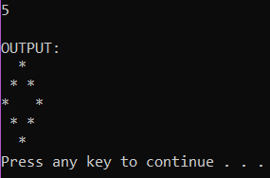

**Q8:** Nhap n so nguyen,~~in ra binh phuong cac so chan trong day~~ , giua 2 so in ra co dau xuong dong \n

Vi du:

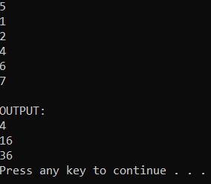

**Q9:** Nhap n so nguyen, in ra cac so le o vi tri le theo thu tu tang dan, voi vi tri dau cua mang = 0, co dau xuong dong giua 2 so in ra \n

Vi du:

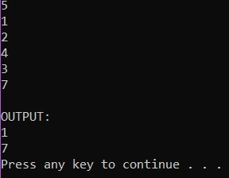

**Q10:** Nhap 7 so nguyen, in ra so co 3 chu so xuat hien nhieu nhat. Neu khong co, in 'No three-digit number'. Nhieu hon 1 so thoa man, in ra va sap xep tang dan, giua 2 so co khoang cach.

Vi du:

